This is a demo Laravel project to manage support tickets between regular users, agents, and admins.

A system to manage support tickets. Customers register as users and can create tickets, then admins assign them to agents, and all parties can view ticket statuses.

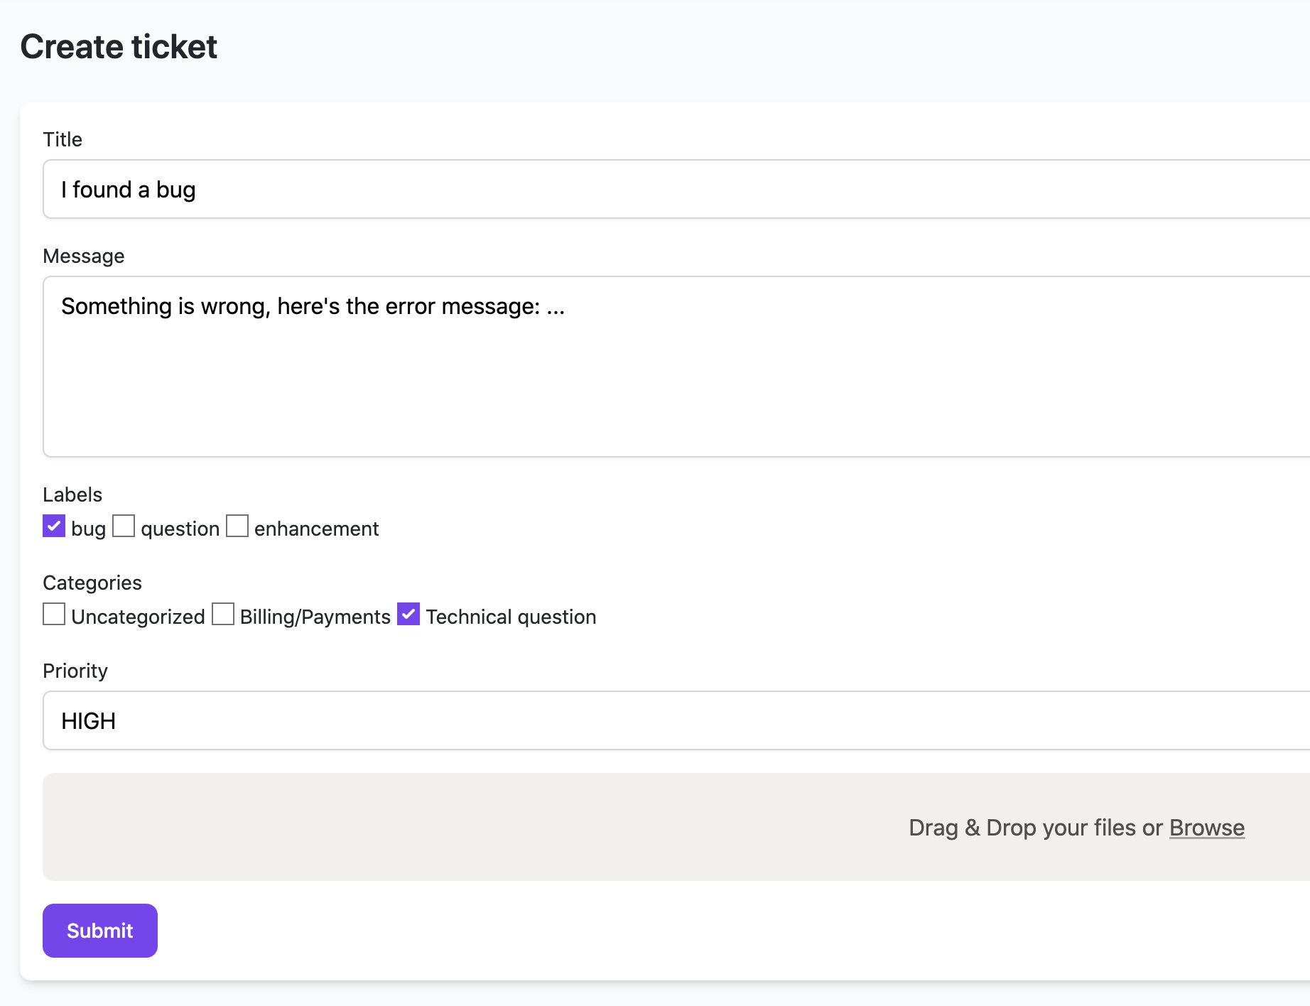

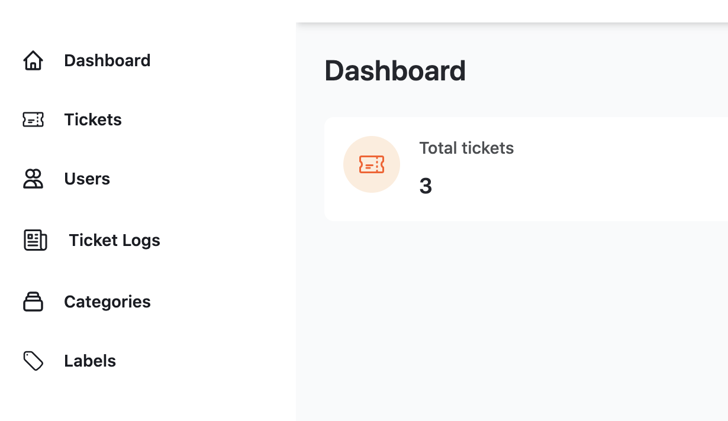

### **Database structure**

Every ticket needs to have:

* title (required)
* text description (required)
* multiple files attached (optional)
* priority (choose from a few options)
* status (choose from a few options like open/closed)
* assigned user agent (foreign key to users table)
* multiple categories (belongsToMany relationship with categories table)
* multiple labels (belongsToMany relationship with labels table)

### **Auth**

There should be login and register functionality, they may come from a starter kit like Laravel Breeze or another one of your choice.

Every user needs to have one of three roles:

* Regular user (default)
* Agent
* Administrator

New users can register and they are assigned a Regular articles role.

There should be one Administration user created with database seeds.

After registration or login, users get inside the system which would look like a typical admin panel to manage data: menus, tables, CRUDs for administrators.

### **Regular users: manage THEIR tickets**

After registration/login, the user sees the only menu item "Tickets" with a table of tickets only created by themselves.

Table of tickets needs to have dropdown filters: by status, priority and category.

They can add a new ticket, but can't edit/delete tickets.

They can click the ticket title in the table to open the page to see more details and ticket activity log and comments, also may add a comment there (more on that later).

### **Agent users: manage THEIR tickets**

Similar to regular users, agents see only tickets, and only their tickets, but "their" has different meaning - not that they created the tickets, but are assigned to them (by admin, more on that later).

They can edit tickets and add comments.

### **Admin users: manage everything**

Admins see not only tickets table, but also can view more menu items:

* Dashboard with the amount of tickets per status (total / open / closed, etc.)
* Manage Labels, Categories, Priorities and Users, in CRUD way

Also, when editing the ticket, admins can assign an Agent user to it - other users shouldn't see that field.

Also, admins should see the menu item called "Logs" which lists all changes that happened to all tickets, like history: who created/updated the ticket and when.

### **Ticket Comments**

After clicking on a ticket, any user can get to its page, and there should be a form to add a comment, and that page shows the list of comments, like on a typical blog post page.

### **Email Notifications**

When the new ticket is created, the admin should get an email with the link to the Edit form of the ticket.